Flattening in CNN:

Let’s take example of simple example given below where there are 64 kernels of dim 3\*3 and i/p is of dimension 3\*32\*32.

Now the output from first layer will be of dim 64\*32\*32

Now we want to add a dense layer so for this we need to conver 3D-tensor into 1D that means we flatten which is called flattening

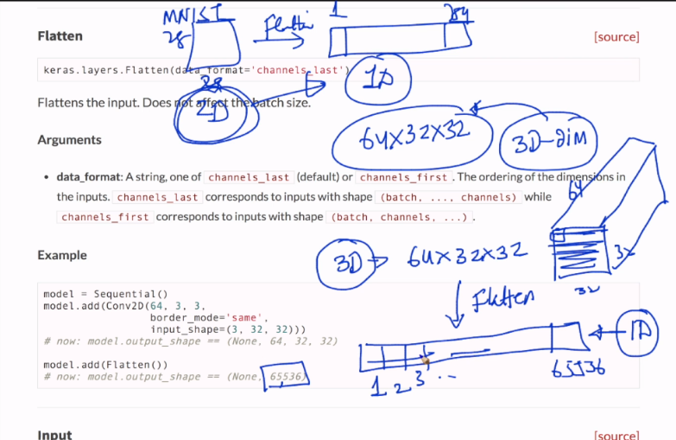

<https://github.com/DustinAlandzes/mnist-lenet-keras/blob/master/lenet.py>

<https://keras.io/layers/convolutional/>

<https://keras.io/layers/pooling/>

<https://keras.io/layers/core/#flatten>

<https://blog.goodaudience.com/introduction-to-1d-convolutional-neural-networks-in-keras-for-time-sequences-3a7ff801a2cf>